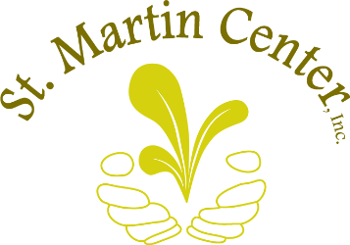
“I alone cannot change the world, but I can cast a stone across the waters to create many ripples.” – Mother Teresa
Please accept our sincere thanks for requesting information about designating grant funding from your Donor Advised Fund to St. Martin Center Inc. With your generosity, you will be able to impact more lives by providing your community members with food, ensuring they have electricity and water, and ensuring their children have access to quality early education. Most importantly, your gift will contribute to the advancement of families. By giving to St. Martin Center, you enable us to provide them not just with the immediate needs of today, but also with the resources, guidance, and tools that they will need to continue to thrive into the future. We cannot thank you enough for this.
In order to designate funds to St. Martin Center Inc., you may need the following information (Consult with your sponsoring organization.):
- Identify the grant recommendation amount.
- Organization Name and Address:
St. Martin Center Inc.
1701 Parade Street
Erie, Pa 16503

- EIN # 25-1211464
- Once approved, 100% of the designated amount will be transferred to St. Martin Center
- If desired, specific information as to where the funds should be utilized, i.e. the Self-Sufficiency Department, the Early Learning Center or Where the need is greatest.
We hope that this information is helpful to you. If you have any further questions or assistance, please do not hesitate to call me at (814) 452-6113 x 216.
Thank you for thinking of our community and the wonderful people we serve.

Sincerely,
Jessica Krugger
Director of Development

