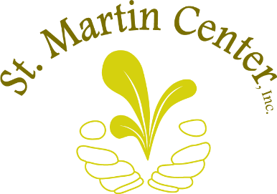
“I alone cannot change the world, but I can cast a stone across the waters to create many ripples.” – Mother Teresa
Please accept our sincere thanks for requesting information about leaving your estate to St. Martin Center Inc. You will leave a lasting impact in your community by ensuring your legacy lives on after you pass. With your generosity, we will be able to impact more lives for years to come. Providing your community members with food, ensuring they have electricity and water, and ensuring their children have access to quality early education are all the services your gift will accomplish. Most importantly, your gift will contribute to the advancement of families. By giving to St. Martin Center, you enable us to provide them not just with the immediate needs of today, but also with the resources, guidance, and tools that they will need to continue to thrive into the future. We cannot thank you enough for this.
*Legal and tax advice should be sought if choosing this option.
In order to name St. Martin Center Inc. in your estate plans, consider the following information,
(Please advise with your estate attorney, if you do not have one, we have some recommendations for you to consider.):
- Complete a Planned Giving Intention Form
- Identify the amount (or a percentage of your estate).
- If desired, specific information as to where the funds should be utilized, i.e. the Self-Sufficiency Department, the Early Learning Center or Where the need is greatest.
- EIN # 25-121464
- Organization Name and Address:
St. Martin Center Inc.
1701 Parade Street
Erie, Pa 16503

We hope that this information is helpful to you. If you have any further questions or assistance, please do not hesitate to call me at (814) 452-6113 x 217.
Thank you for making your mark on this community and to the wonderful people we serve.

Sincerely,
Ellie Roberts
Donor Advisor

